# Group Members and Roles

# IMG_20170124_172728Luke Cattle

Luke’s work includes the automation of the Tri-Track as well as designing new methods to control the arm with an IMU, and develop a voice command system.

# Callum Newman

# 

Working on route navigation for the DaNI bot as well as designing and manufacturing the laser guidance system

# Ben Peall

# 

Ben is currently working on automation of the Tri-track arm using the raspberry pi and opencv as well as general Tri-track controls for movement in the environment.

# Josh Crawford

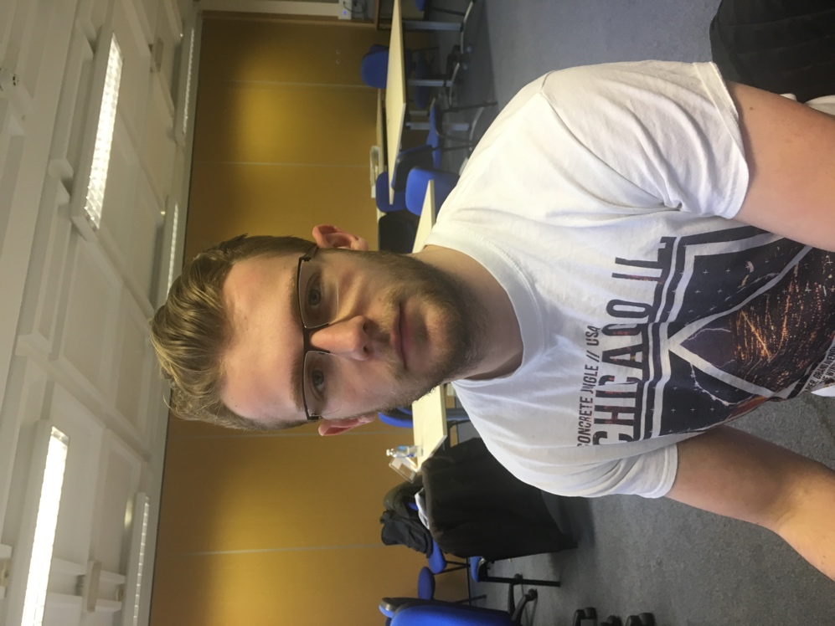

Josh is working on adapting the Microsoft Kinect sensor to detect and track objects, work with the laser gimbal system, also looking to utilise the Kinect sensor microphone for acoustic localisation of the black box.

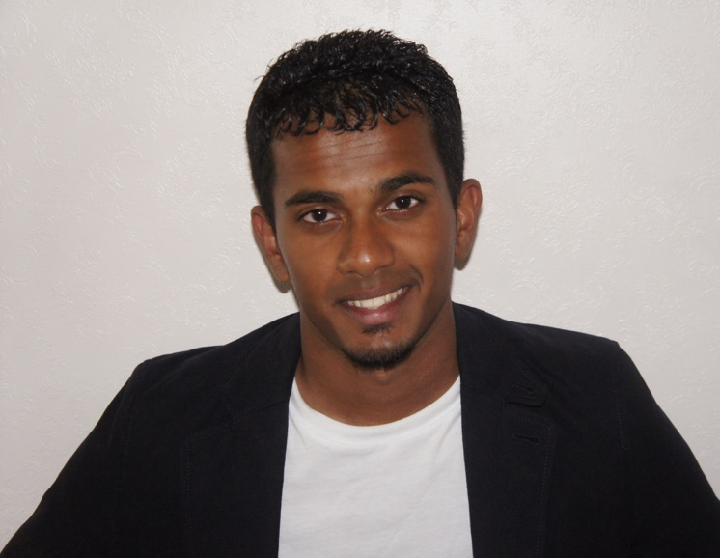Jonathan Balakumar

Jonathan is working on designing and manufacturing the laser guidance system; producing and maintaining systems documentation. He has recently joined the subgroup to work on route navigation for the Dani bot.